[www.oracle.com/academy](http://www.oracle.com/academy)

# Database Programming with SQL 15-1: Creating Views

Practice Solutions

## Vocabulary

Directions: Identify the vocabulary word for each definition below.

|  |  |
| --- | --- |
| View | A subset of data from one or more tables that is generated  from a query and stored as a virtual table |
| VIEW_NAME | Name of view |
| FORCE | Creates a view regardless of whether or not the base tables exist |
| Simple view | Derives data from one table, no functions or groups, performs  DML operations through the view |
| NOFORCE | Creates the view only if the base table exists |
| CREATE VIEW | Statement used to create a new view |
| Alias | Specifies a name for each expression selected by the view’s query |
| Subquery | A complete SELECT statement |
| Complex view | Derives data from one or more tables, contains functions or groups of data, and does not always allow DML operations  through the view |
| REPLACE | Re-creates the view if it already exists |

## Try It / Solve It

1. What are three uses for a view from a DBA’s perspective?

### Solution:

Any 3 from the following:

* + To restrict access to the data because the view can display selective columns from the table.
  + To reduce the complexity of executing queries based on more complicated SELECT statements.
  + To retrieve data from several tables, providing data independence for users. Users can view the same data in different ways.
  + To provide groups of users with access to data according to their particular permis- sions or criteria.

1. Create a simple view called view_d_songs that contains the ID, title and artist from the DJs on Demand table for each “New Age” type code. In the subquery, use the alias “Song Title” for the title column.

### Solution:

CREATE VIEW view_d_songs

AS SELECT id, title AS "Song Title", artist FROM d_songs

WHERE type_code = 77;

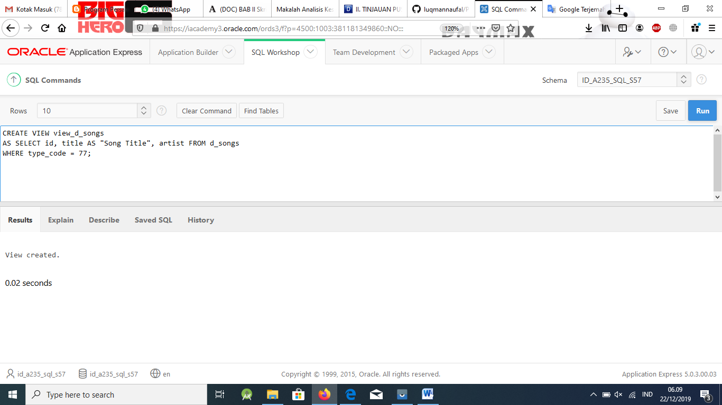

1. SELECT * FROM view_d_songs. What was returned?

### Solution:

SELECT *

FROM view_d_songs;

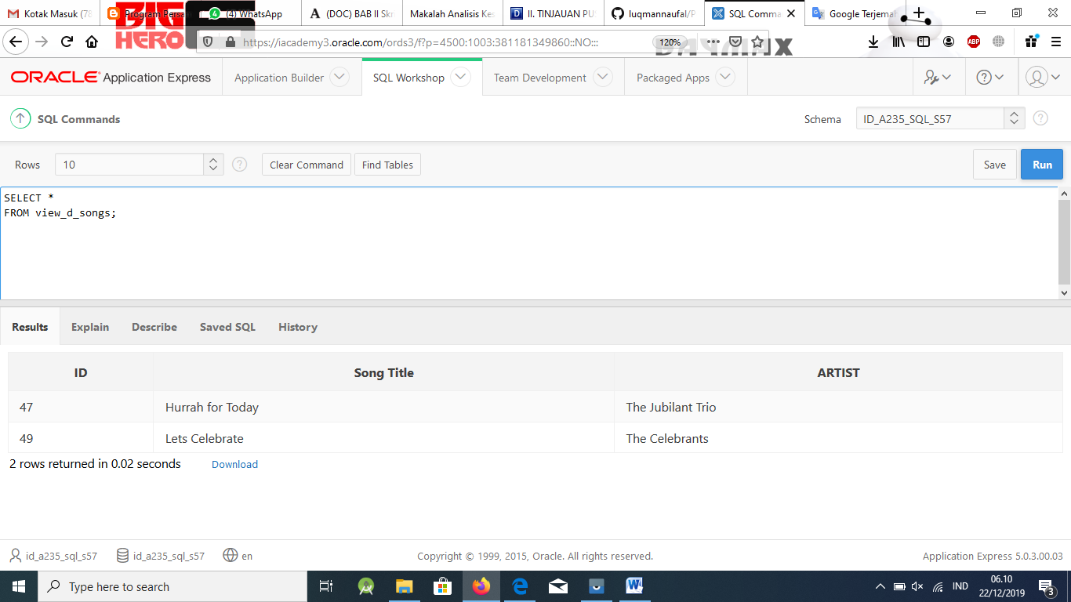

1. REPLACE view_d_songs. Add type_code to the column list. Use aliases for all columns.

### Solution:

CREATE OR REPLACE VIEW view_d_songs

AS SELECT id AS "Identification", title AS "Song Title", artist AS "Recording Artist", type_code AS "Type Code"

FROM d_songs

WHERE type_code = 77;

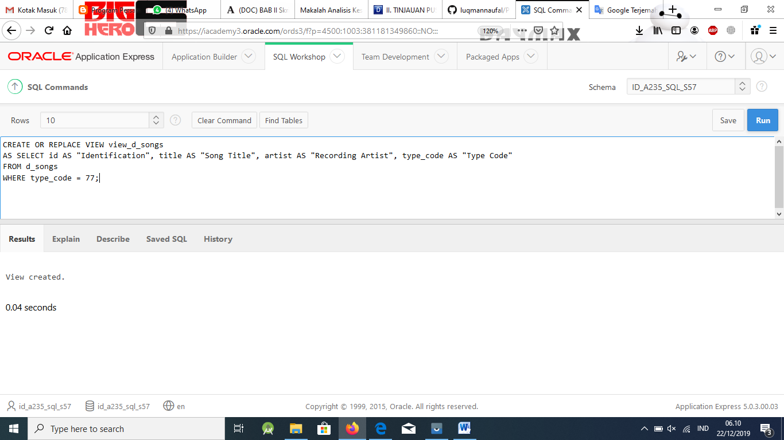

Or use alias after the CREATE statement as shown.

CREATE OR REPLACE VIEW view_d_songs(Identification, Song, Singer, " Type Code") AS SELECT id, title, artist, type_code

FROM d_songs ;

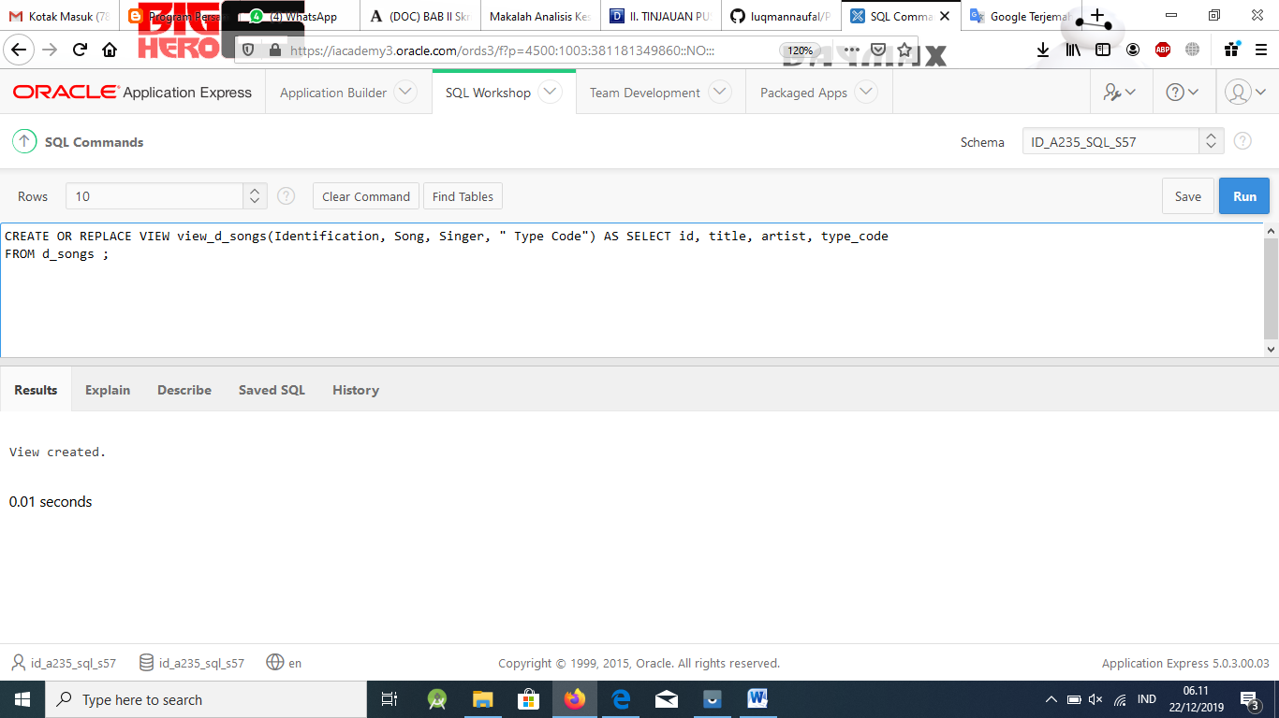

1. Jason Tsang, the disk jockey for DJs on Demand, needs a list of the past events and those planned for the coming months so he can make arrangements for each event’s equipment setup. As the company manager, you do not want him to have access to the price that clients paid for their events. Create a view for Jason to use that displays the name of the event, the event date, and the theme description. Use aliases for each col- umn name.

### Solution:

CREATE OR REPLACE VIEW view_events_dj ("Name of Event", "Event Date", "Theme Code", "Description")

AS SELECT e.name, e.event_date, e.theme_code, t.description FROM d_events e, d_themes t

WHERE e.theme_code = t.code;

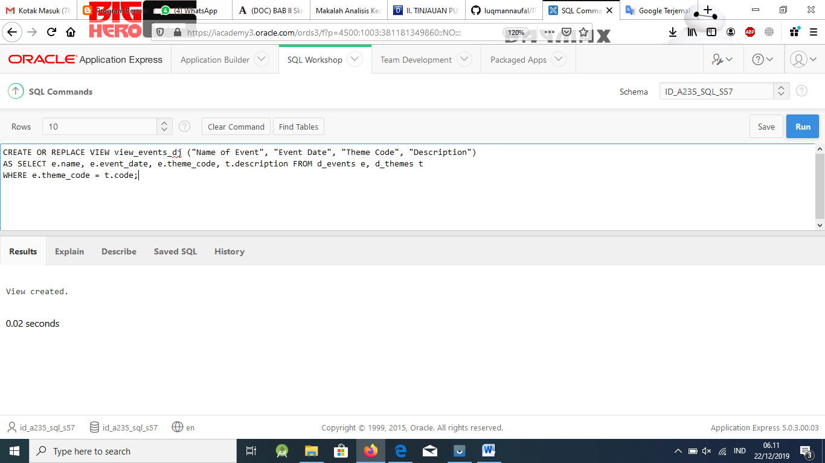

1. It is company policy that only upper-level management be allowed access to individual employee salaries. The department managers, however, need to know the minimum, max- imum, and average salaries, grouped by department. Use the Oracle database to prepare a view that displays the needed information for department managers.

### Solution:

CREATE VIEW dept_sum_vu (name, minsal, maxsal, avgsal)

AS SELECT d.department_name, MIN(e.salary), MAX(e.salary),AVG(e.salary) FROM employees e, departments d

WHERE e.department_id = d.department_id GROUP BY d.department_name;

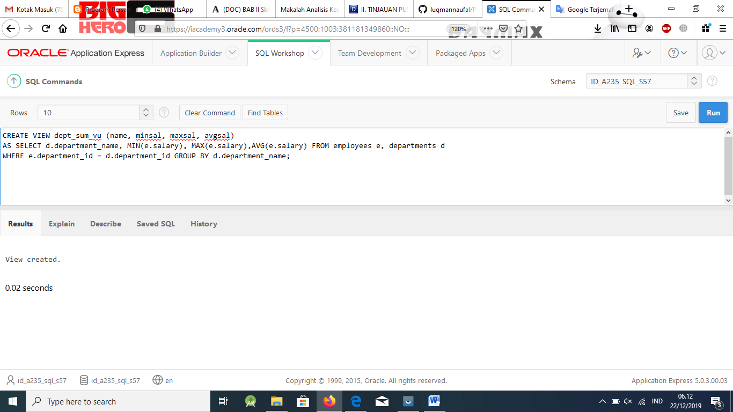

[www.oracle.com/academy](http://www.oracle.com/academy)

Database Programming with SQL 15-2: DML Operations and Views Practice Solutions

# Vocabulary

Directions: Identify the vocabulary word for each definition below.

|  |  |
| --- | --- |
| **ROWNUM** | A pseudo-column which assigns a sequential value  starting with 1 to each of the rows returned from the subquery |
| **WITH CHECK OPTION** | Specifies that INSERTS and UPDATES performed through the view can’t create rows which the view cannot select |
| **WITH READ ONLY** | Ensures that no DML operations can be performed on  this view |

# Try It / Solve It

Use the DESCRIBE statement to verify that you have tables named copy_d_songs, copy_d_events, copy_d_cds, and copy_d_clients in your schema. If you don’t, write a query to create a copy of each.

1. Query the data dictionary USER_UPDATABLE_COLUMNS to make sure the columns in the base tables will allow UPDATE, INSERT, or DELETE. Use a SELECT statement or the Browse Data Dictionary feature in HTML DB. All table names in the data dictionary are stored in uppercase.

## Solution:

SELECT *

FROM USER_UPDATABLE_COLUMNS

WHERE table_name = 'COPY_D_SONGS';

Use the same syntax but change table_name of the other tables.

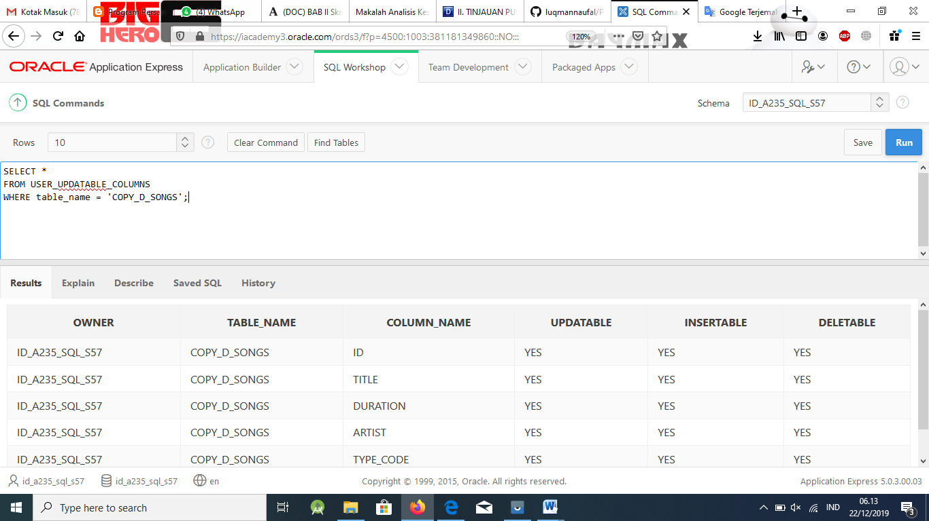

1. Use the CREATE or REPLACE option to create a view of *all* the columns in the copy_d_songs table called view_copy_d_songs.

## Solution:

CREATE VIEW view_copy_d_songs AS SELECT *

FROM copy_d_songs;

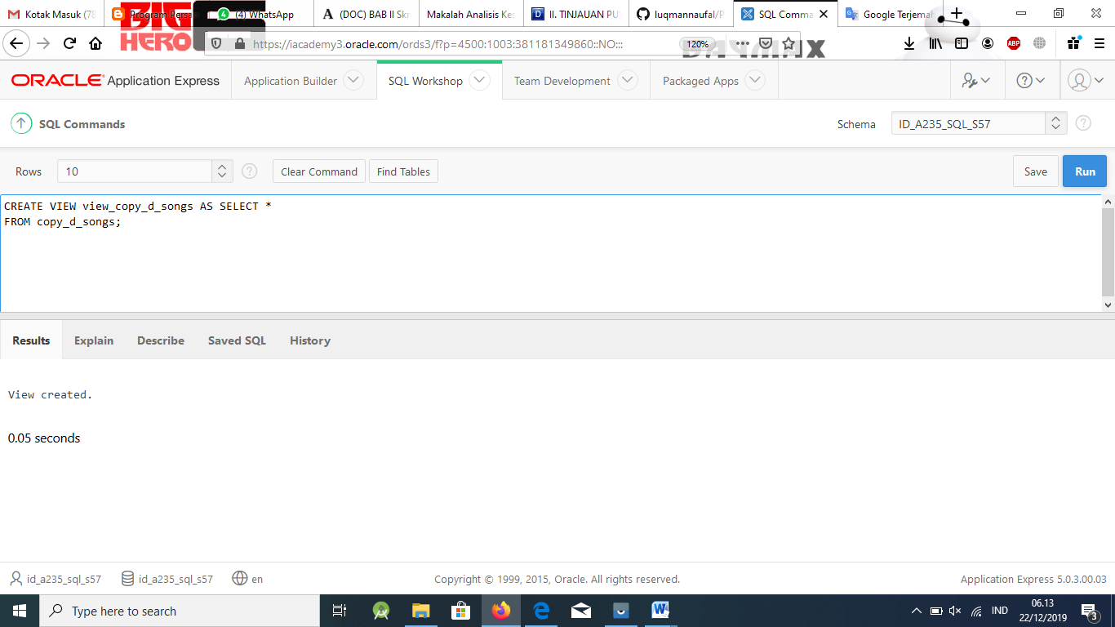

1. Use view_copy_d_songs to INSERT the following data into the underlying copy_d_songs table. Execute a SELECT * from copy_d_songs to verify your DML command. See the graphic.

|  |  |  |  |  |
| --- | --- | --- | --- | --- |
| ID | TITLE | DURATION | ARTIST | TYPE_CODE |
| 88 | Mello Jello | 2 | The What | 4 |

## Solution:

INSERT INTO view_copy_d_songs(id, title, duration, artist, type_code)

VALUES(88, 'Mellow Jello', '2', 'The What', 4);

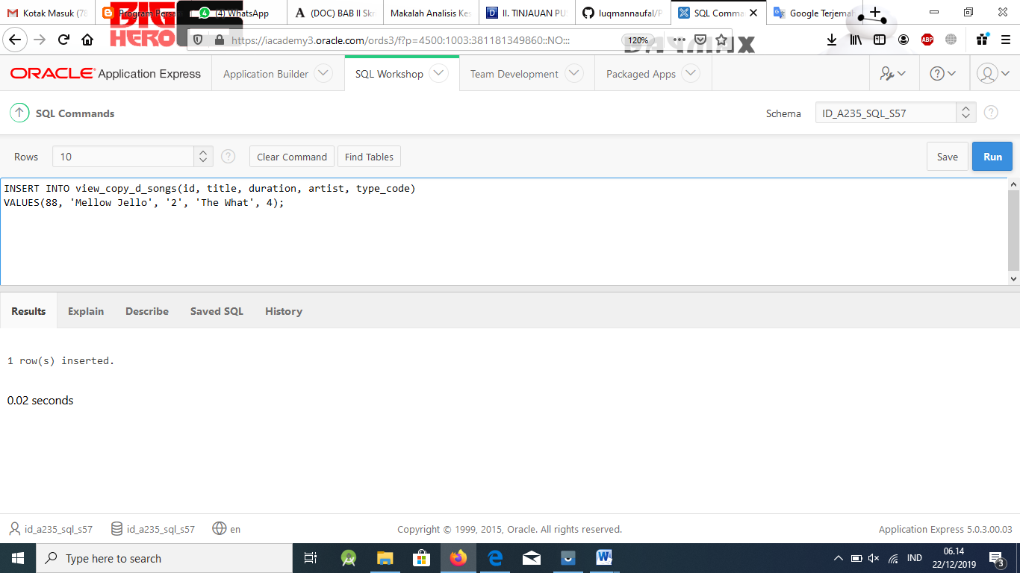

SELECT *

FROM view_copy_d_songs;

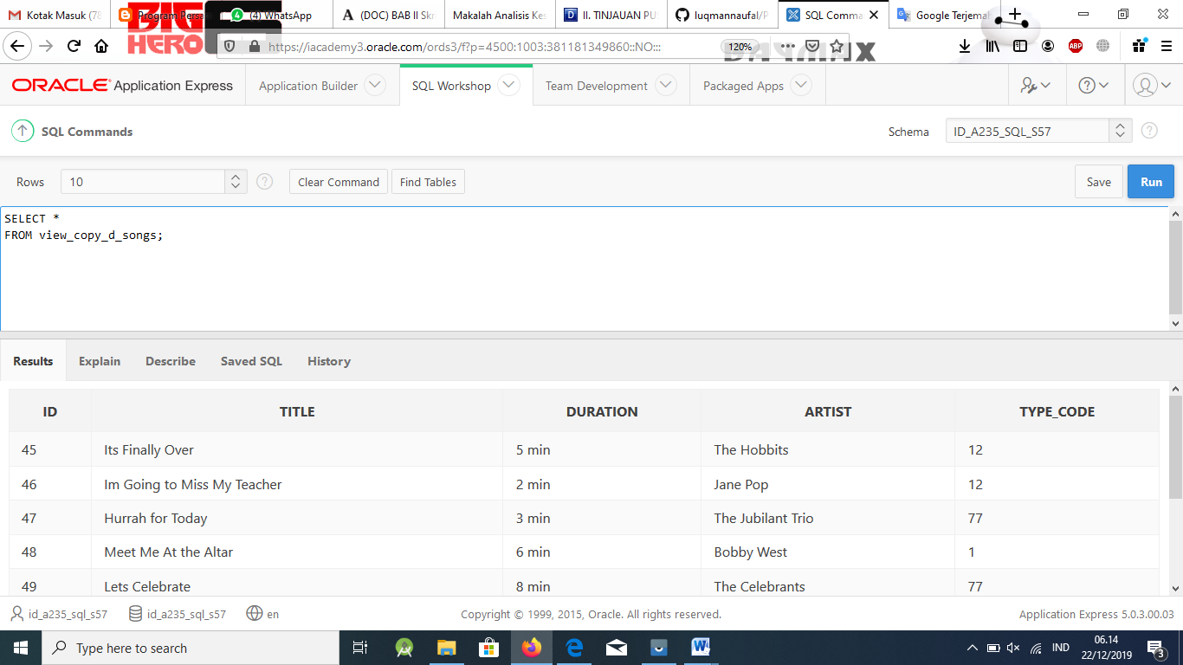

SELECT *

FROM copy_d_songs;

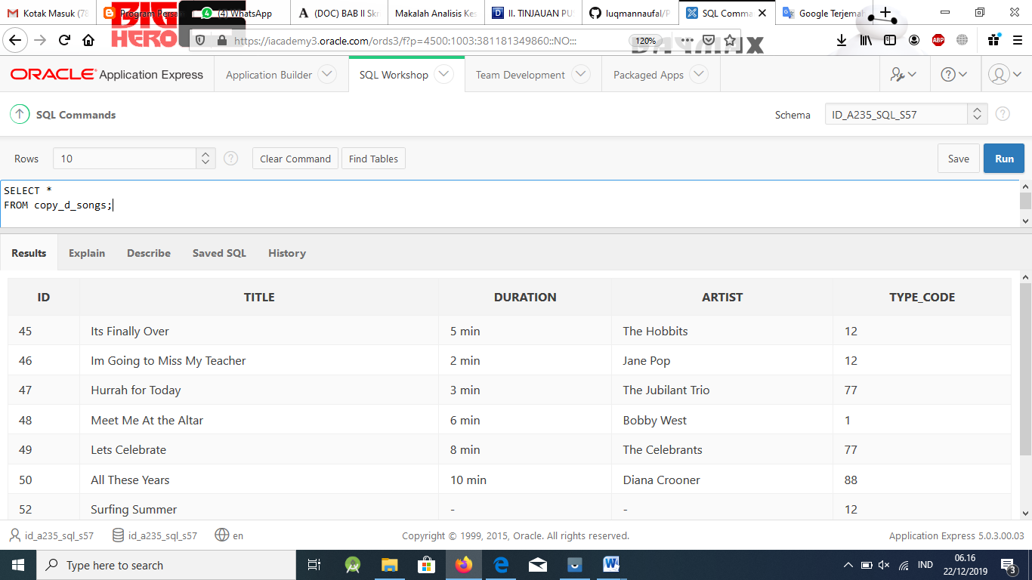

1. Create a view based on the DJs on Demand COPY_D_CDS table. Name the view read_copy_d_cds. Select all columns to be included in the view. Add a WHERE clause to restrict the year to 2000. Add the WITH READ ONLY option.

## Solution:

CREATE VIEW read_copy_d_cds AS SELECT *

FROM copy_d_cds WHERE year = 2000 WITH READ ONLY;

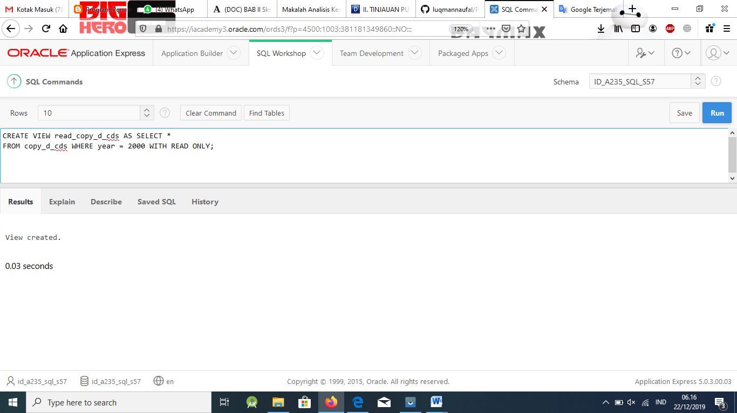

1. Using the read_copy_d_cds view, execute a DELETE FROM read_copy_d_cds WHERE cd_number = 90;

## Solution:

DELETE FROM read_copy_d_cds WHERE cd_number = 90;

**fail to execute as view is read only

ORA-01752: cannot delete from view without exactly one key-preserved table

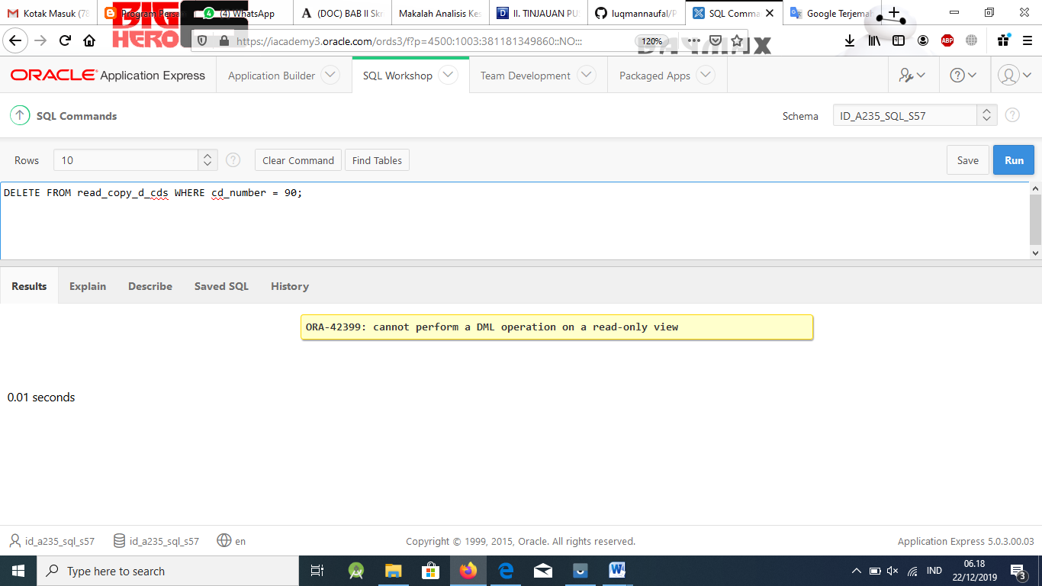

1. Use REPLACE to modify read_copy_d_cds. Replace the READ ONLY option with WITH CHECK OPTION CONSTRAINT ck_read_copy_d_cds. Execute a SELECT * statement to verify that the view exists.

## Solution:

CREATE OR REPLACE VIEW read_copy_d_cds AS SELECT *

FROM copy_d_cds WHERE year = 2000

WITH CHECK OPTION CONSTRAINT ck_read_copy_d_cds;

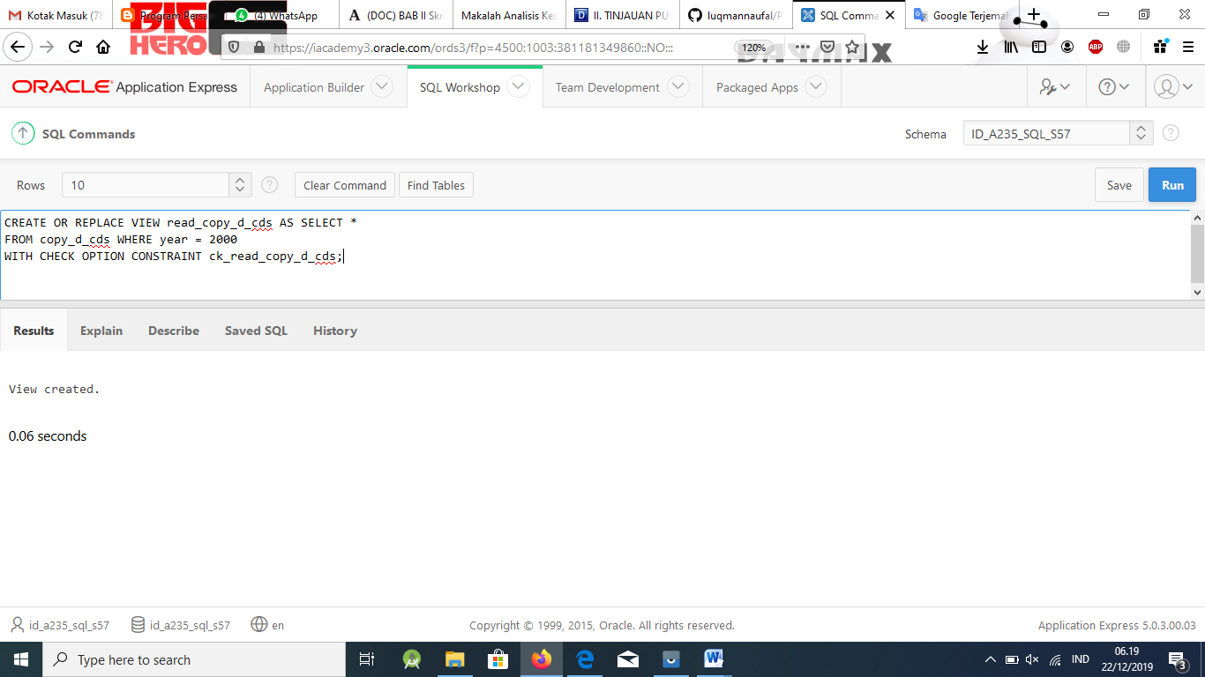

1. Use the read_copy_d_cds view to delete any CD of year 2000 from the underlying copy_d_cds.

## Solution:

DELETE FROM read_copy_d_cds WHERE year = 2000;

**executes as it meets the CHECK OPTION criteria

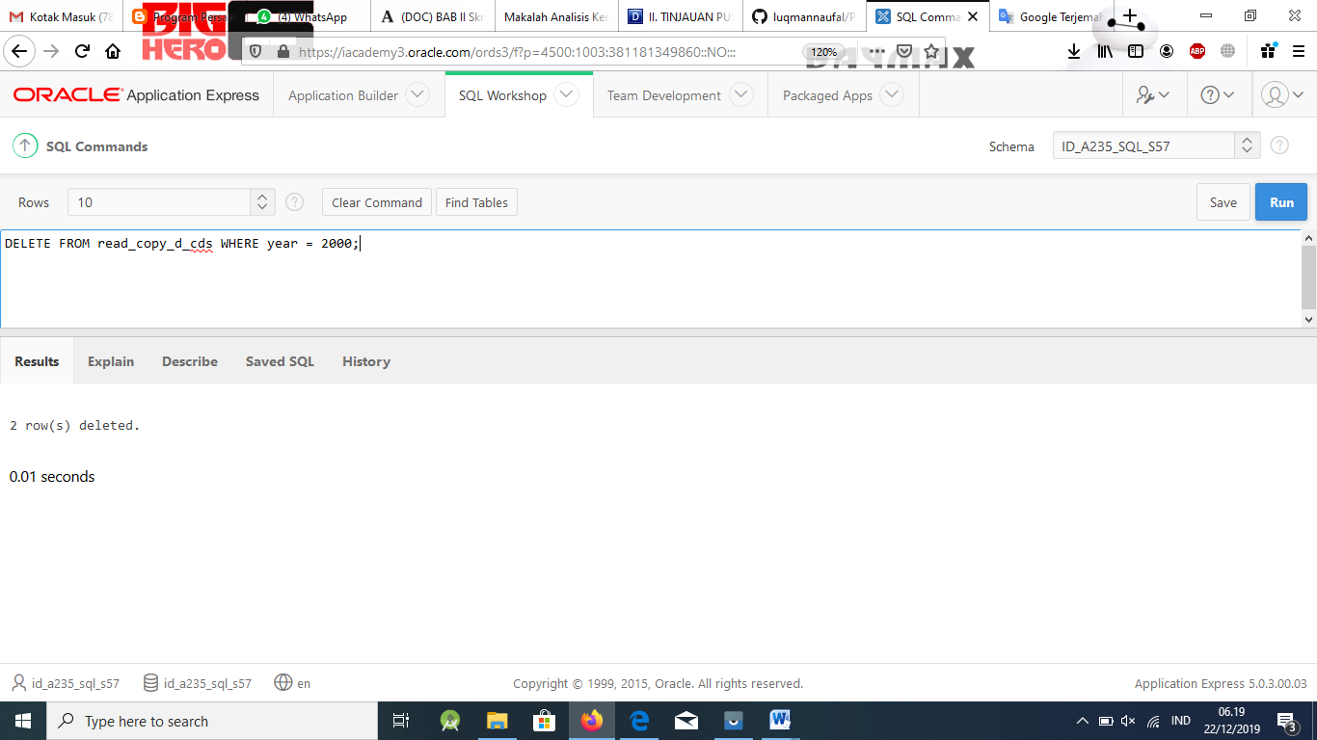

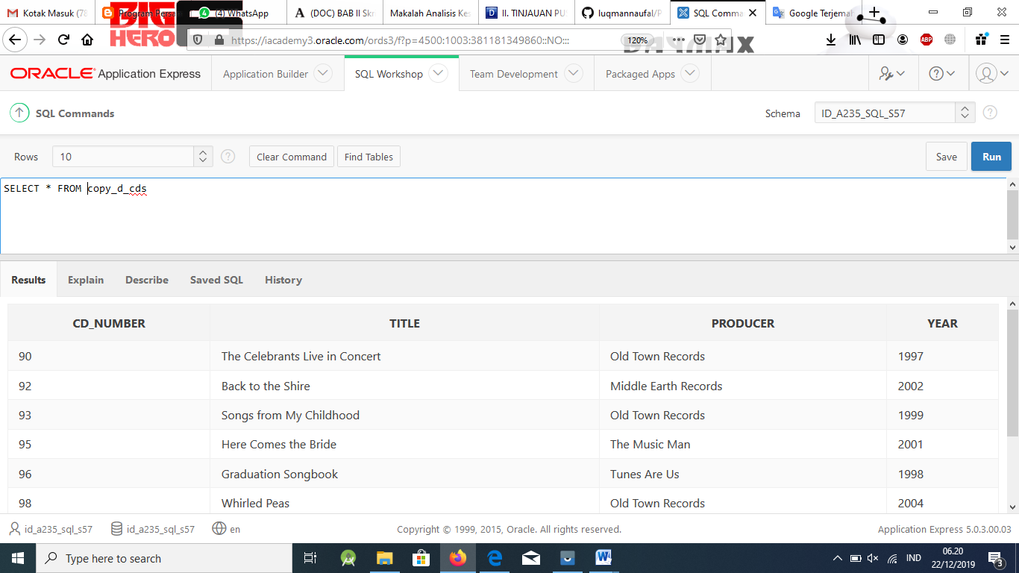

1. Use the read_copy_d_cds view to delete cd_number 90 from the underlying copy_d_cds table.

## Solution:

DELETE FROM read_copy_d_cds WHERE cd_number = 90;

**query executes with 0 rows deleted

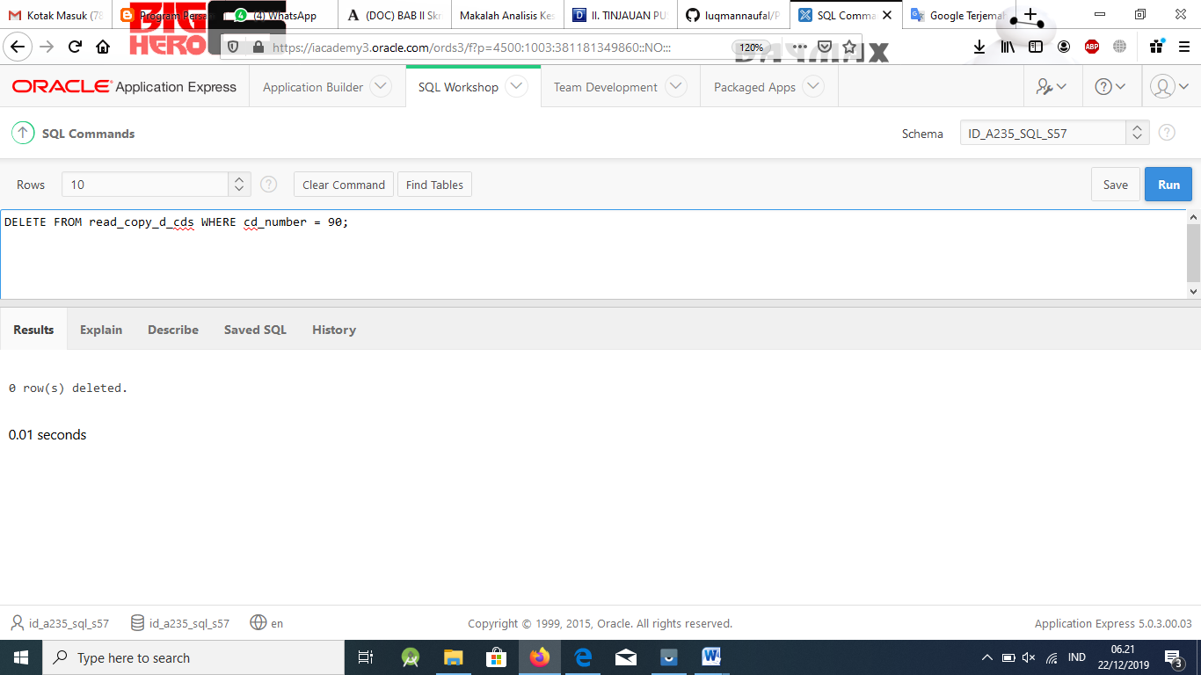

1. Use the read_copy_d_cds view to delete year 2001 records.

## Solution:

DELETE FROM read_copy_d_cds WHERE year = 2001;

**query executes with 0 rows deleted

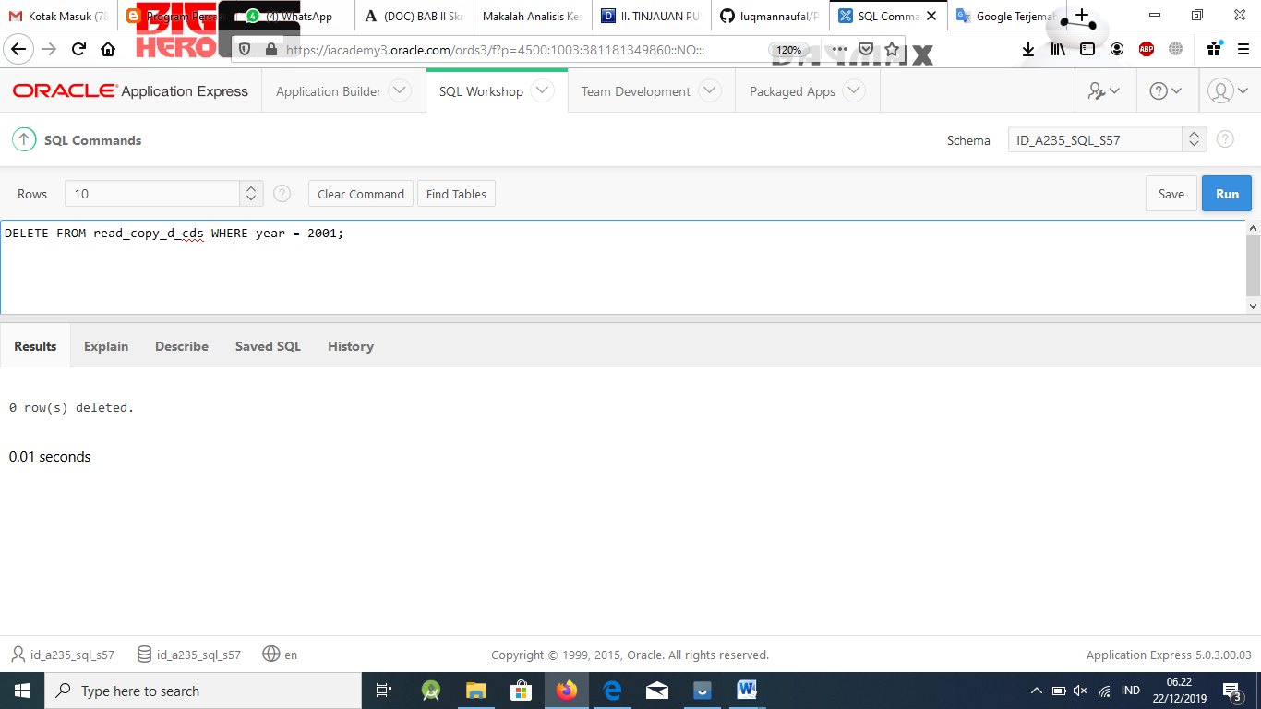

1. Execute a SELECT * statement for the base table copy_d_cds. What rows were deleted?

## Solution:

The base tables should have all original rows with no year 2000 data.

1. What are the restrictions on modifying data through a view?

## Solution:

A row cannot be removed if the row contains:

* + Group functions
  + A GROUP BY clause
  + The DISTINCT keyword
  + The pseudo-column ROWNUM Keyword

Data cannot be modified if the view contains:

* + Group functions
  + A GROUP BY clause
  + The DISTINCT keyword
  + The pseudo column ROWNUM keyword
  + Columns defined by expressions

Data cannot be added if the view:

* + Includes group functions
  + Includes a GROUP BY clause
  + Includes the DISTINCT keyword
  + Includes the pseudo column ROWNUM keyword
  + Includes columns defined by expressions
  + Does not include NOT NULL columns in the base tables

1. What is Moore’s Law? Do you consider that it will continue to apply indefinitely? Support your opinion with research from the internet.

## Solution:

Moore’s Law states that the number of transistors on a given chip can be doubled every two years.

1. What is the “singularity” in terms of computing?

## Solution:

The singularity – the argument that computing power will improve to the point that it has such an impact on human evolution that it is impossible to determine what will come after.

;

[www.oracle.com/academy](http://www.oracle.com/academy)

# Database Programming with SQL 15-3: Managing Views

Practice Solutions

## Vocabulary

Directions: Identify the vocabulary word for each definition below.

|  |  |
| --- | --- |
| **TOP- N-ANALYSIS** | Asks for the N largest or smallest values in a column |
| **DROP VIEW** | Removes a view |
| **INLINE VIEW** | Subquery with an alias that can be used within a SQL statement |

## Try It / Solve It

1. Create a view from the copy_d_songs table called view_copy_d_songs that includes only the title and artist. Execute a SELECT * statement to verify that the view exists.

### Solution:

CREATE OR REPLACE VIEW view_copy_d_songs AS SELECT title, artist

FROM copy_d_songs;

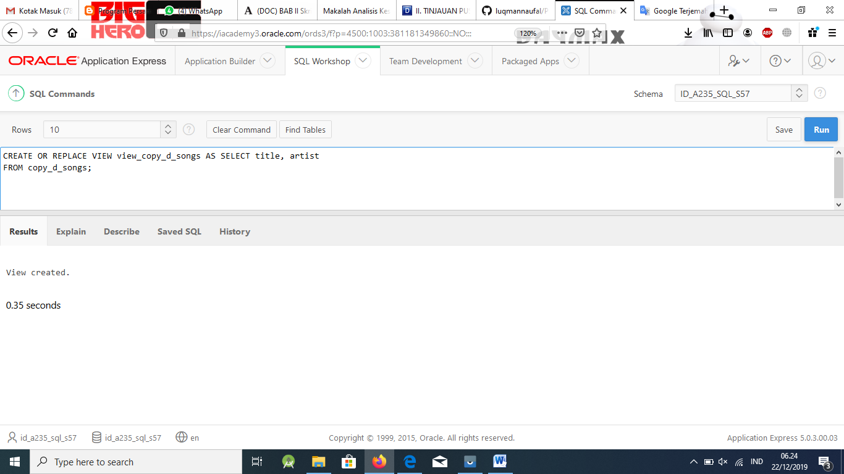

SELECT * FROM view_copy_d_songs;

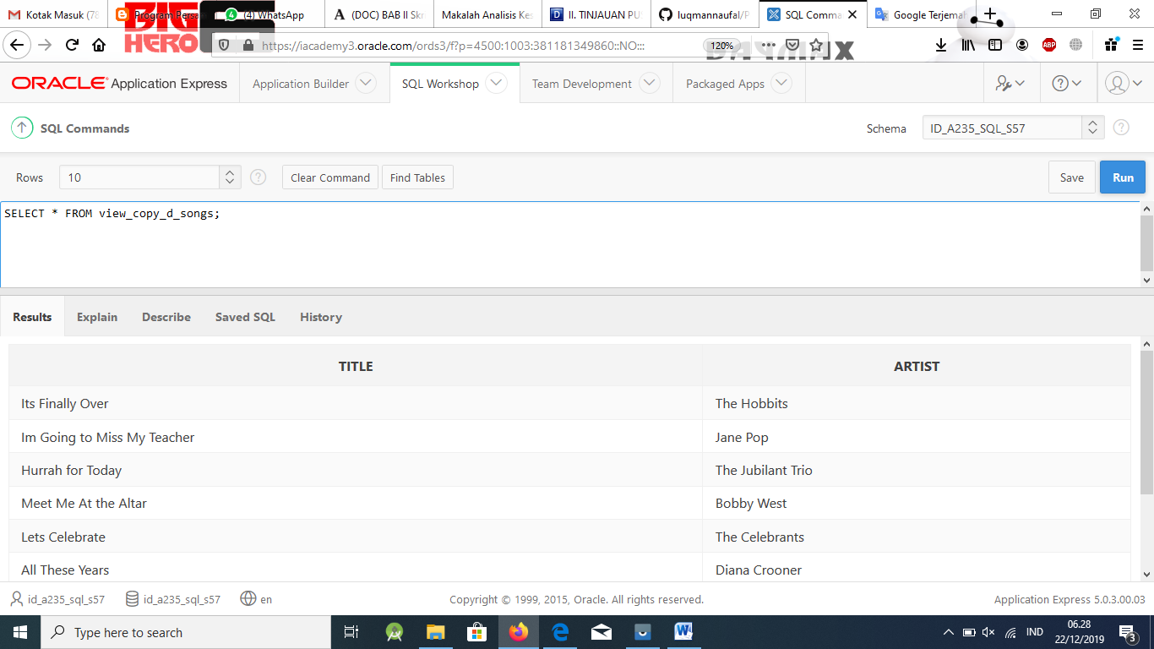

1. Issue a DROP view_copy_d_songs. Execute a SELECT * statement to verify that the view has been deleted.

### Solution:

DROP VIEW view_copy_d_songs;

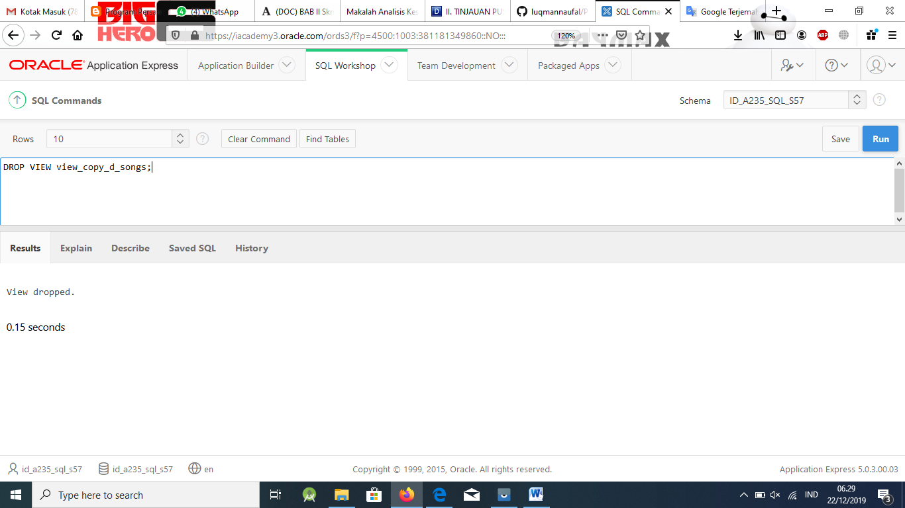

SELECT * FROM view_copy_d_songs;

1. Create a query that selects the last name and salary from the Oracle database. Rank the salaries from highest to lowest for the top three employees.

### Solution:

SELECT ROWNUM as RANK, last_name, salary

FROM (SELECT last_name,salary FROM employees ORDER BY salary DESC) WHERE ROWNUM <= 3;

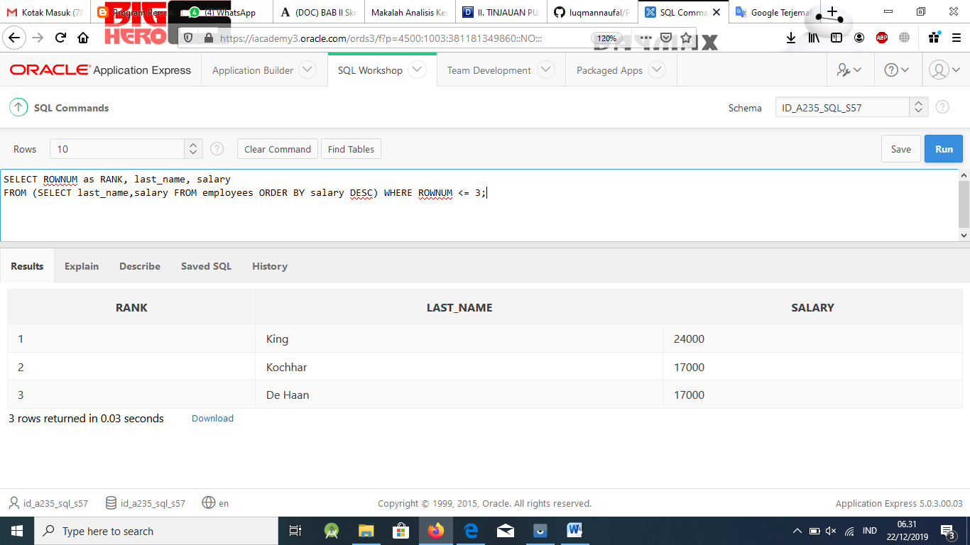

1. Construct an inline view from the Oracle database that lists the last name, salary, depart- ment ID, and maximum salary for each department. Hint: One query will need to calculate maximum salary by department ID.

### Solution:

SELECT a.last_name, a.salary, a.department_id, b.maxsal

FROM employees a, (SELECT department_id, MAX(salary) maxsal FROM employees GROUP BY department_id) b

WHERE a.department_id = b.department_id AND a.salary < b.maxsal;

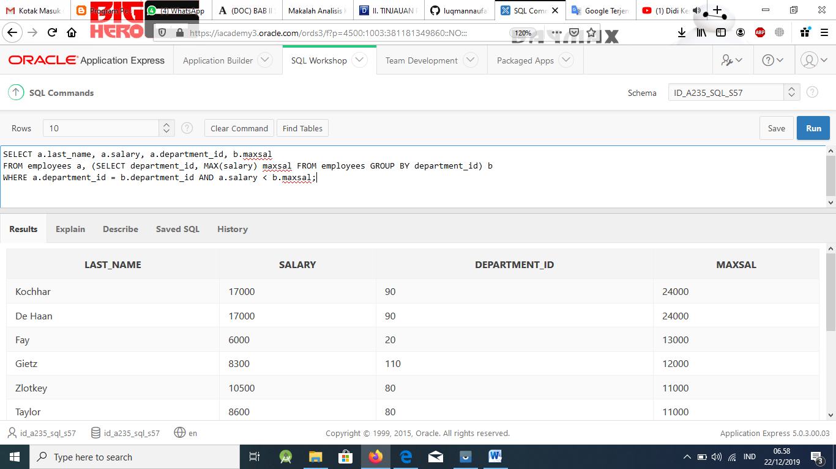

1. Create a query that will return the staff members of Global Fast Foods ranked by salary from lowest to highest.

### Solution:

SELECT ROWNUM as RANK, last_name, salary

FROM (SELECT last_name,salary FROM f_staffs ORDER BY salary ) WHERE ROWNUM <= 3;

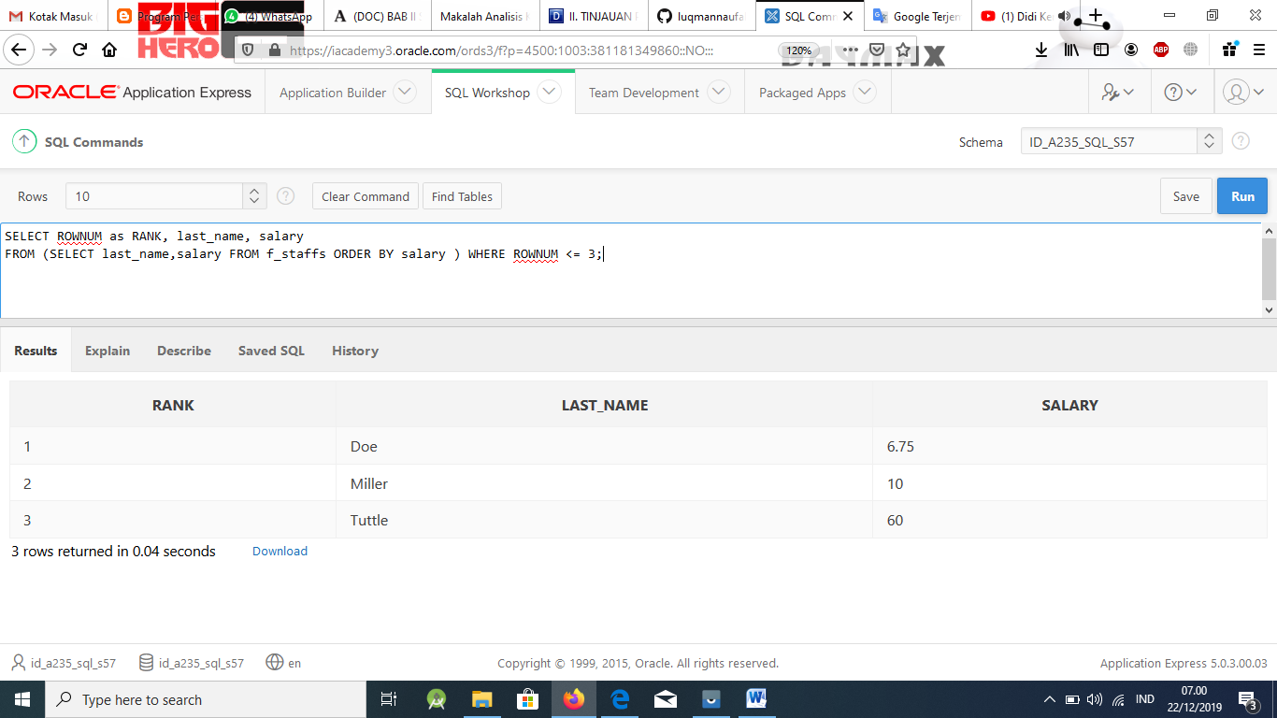

*Extension Exercises*

### NOTE: Students should complete each practice exercise in the order presented. Each subsequent exercise is an extension of the prior exercise. If students make a mistake, a view can be re-created easily with a CREATE or REPLACE VIEW state- ment. If students have difficulty, do one question at a time and review the process for setting up the query and the result set. Review with students the Study Guide and Vocabulary.

1. Create a new table called my_departments and add all columns and all rows to it using a subquery from the Oracle departments table. Do a SELECT * from my_departments to confirm that you have all the columns and rows.

### Solution:

CREATE TABLE my_departments AS SELECT *

FROM departments;

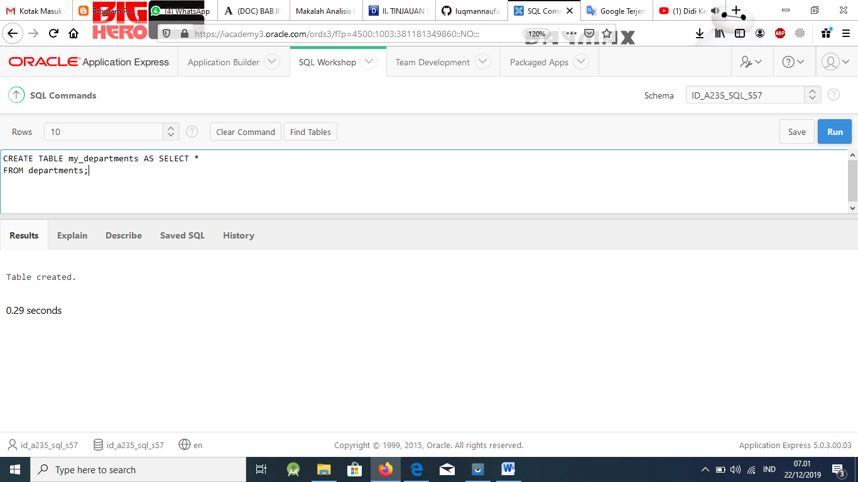

SELECT *

FROM my_departments;

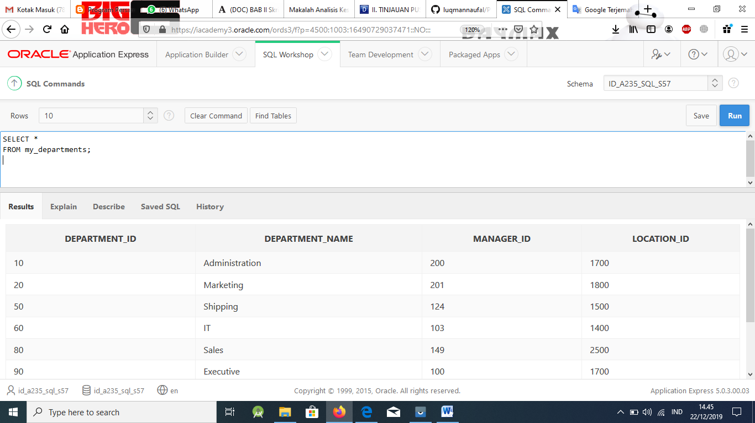

1. To view any constraints that may affect the my_departments table, DESCRIBE my_departments to check if any constraints were carried over from the departments table. If there are constraints on my_departments, use an ALTER TABLE command to DISABLE all constraints on my_departments.

### Solution:

DESCRIBE my_departments;

**department_name is NOT NULL, constraint name is SYS_C001868830 (this name could vary)

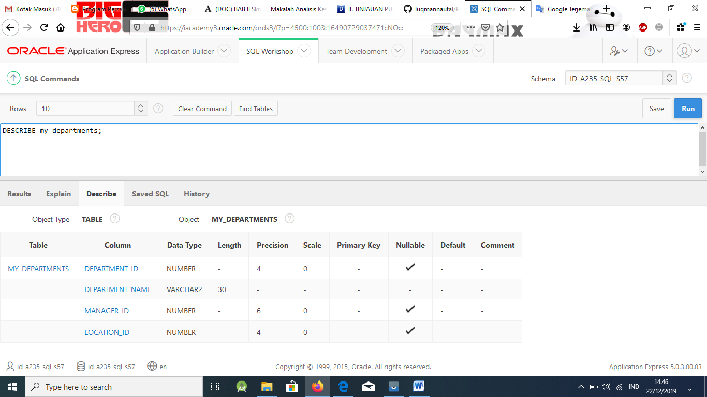

ALTER TABLE my_departments

DISABLE CONSTRAINT SYS_C001868830;

1. Create a view called view_my_departments that includes: department_id and depart- ment_name.

### Solution:

CREATE VIEW view_my_departments

AS SELECT department_id, department_name FROM my_departments;

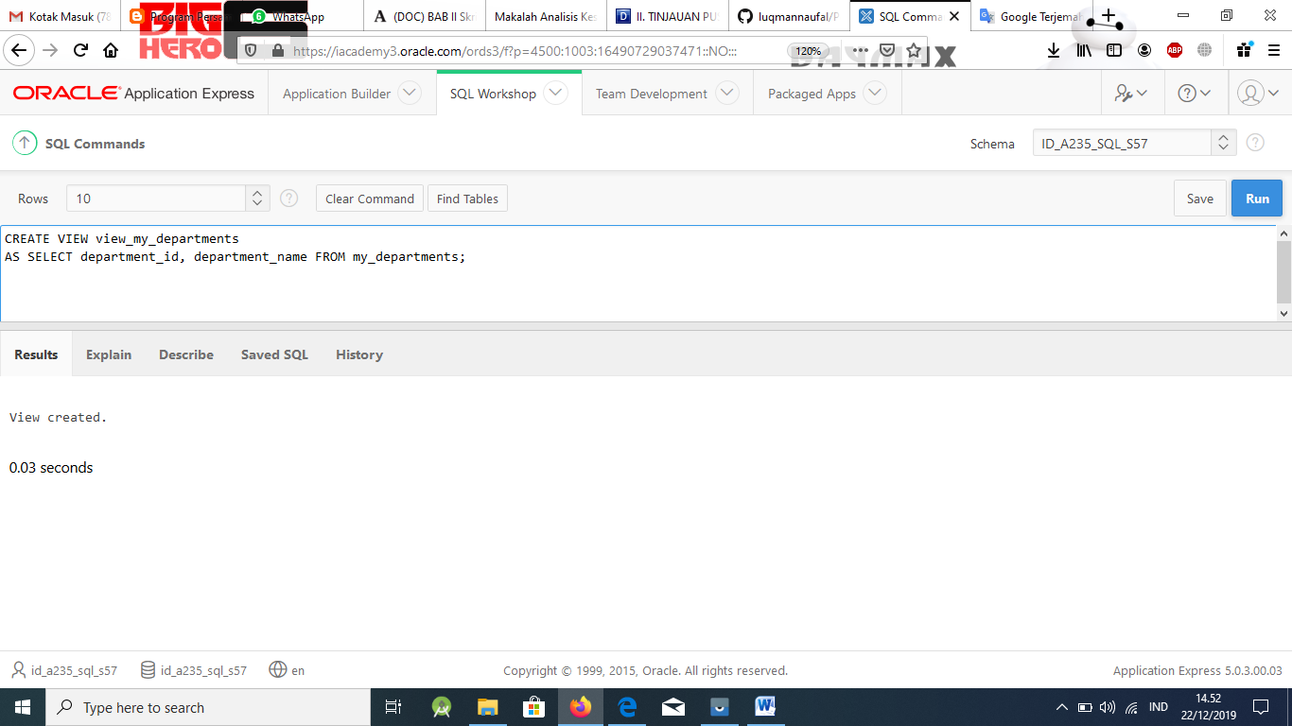

1. Add the following data to the my_departments table using view_my_departments.

|  |  |
| --- | --- |
| department_id | department_name |
| 105 | Advertising |
| 120 | Custodial |
| 130 | Planning |

### Solution:

INSERT INTO view_my_departments(department_id, department_name) VALUES(105, 'Advertising');

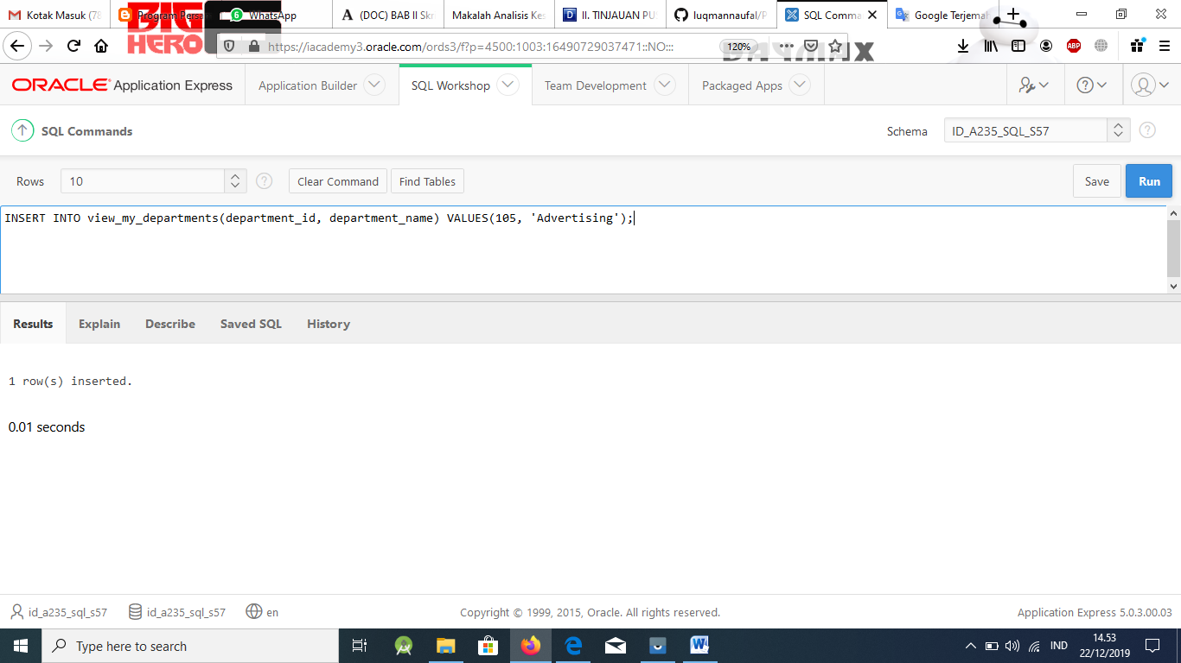

INSERT INTO view_my_departments(department_id, department_name) VALUES(120, 'Custodial');

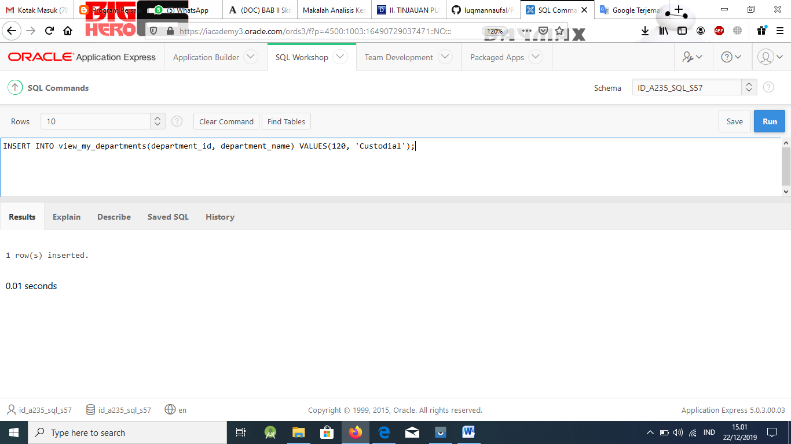

INSERT INTO view_my_departments(department_id, department_name) VALUES(130, 'Planning');

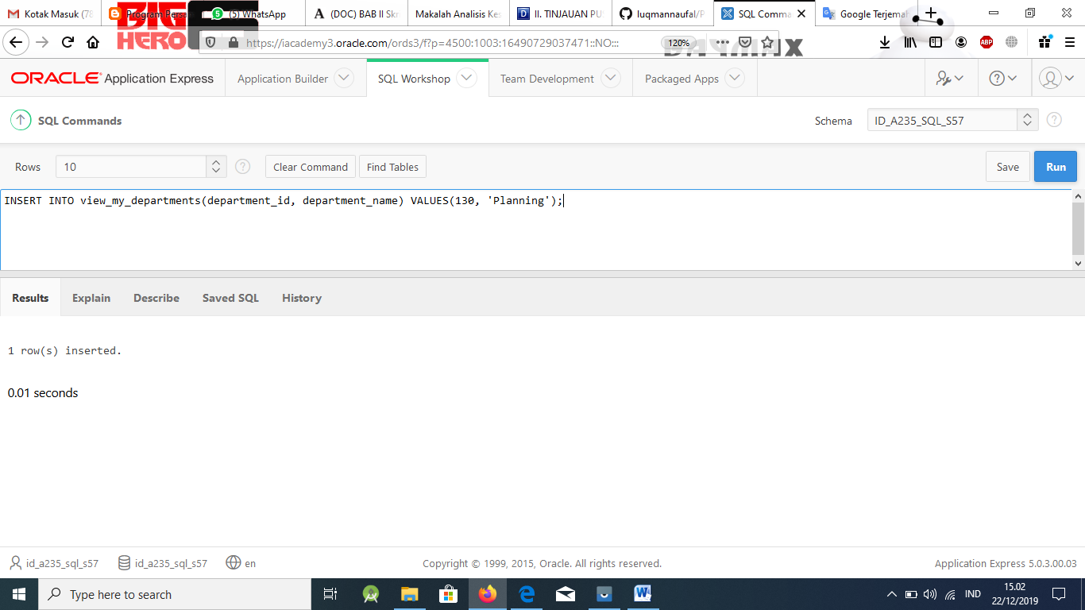

1. Create or enable the department_id column as the primary key.

### Solution:

ALTER TABLE my_departments

ADD CONSTRAINT my_department_id_pk PRIMARY KEY (department_id);

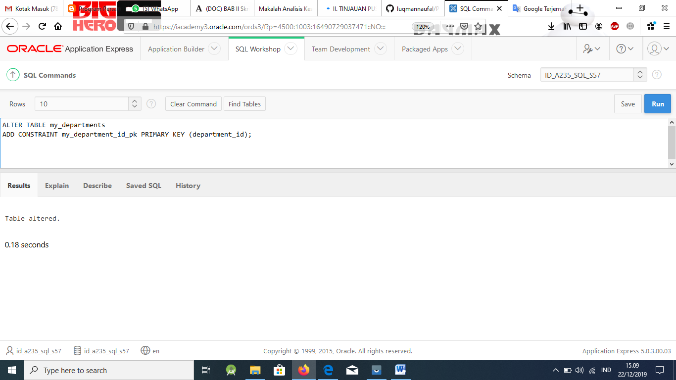

1. Enter a new department named Human Resources into the my_departments table using view_my_departments. Do not add a new department ID.

### Solution:

INSERT INTO view_my_departments (department_name) VALUES('Human Resources');

ORA-01400: cannot insert NULL into ("USWA_SKHS_SQL01_T01"."DEPARTMENTS"."DEPARTMENT_ID")

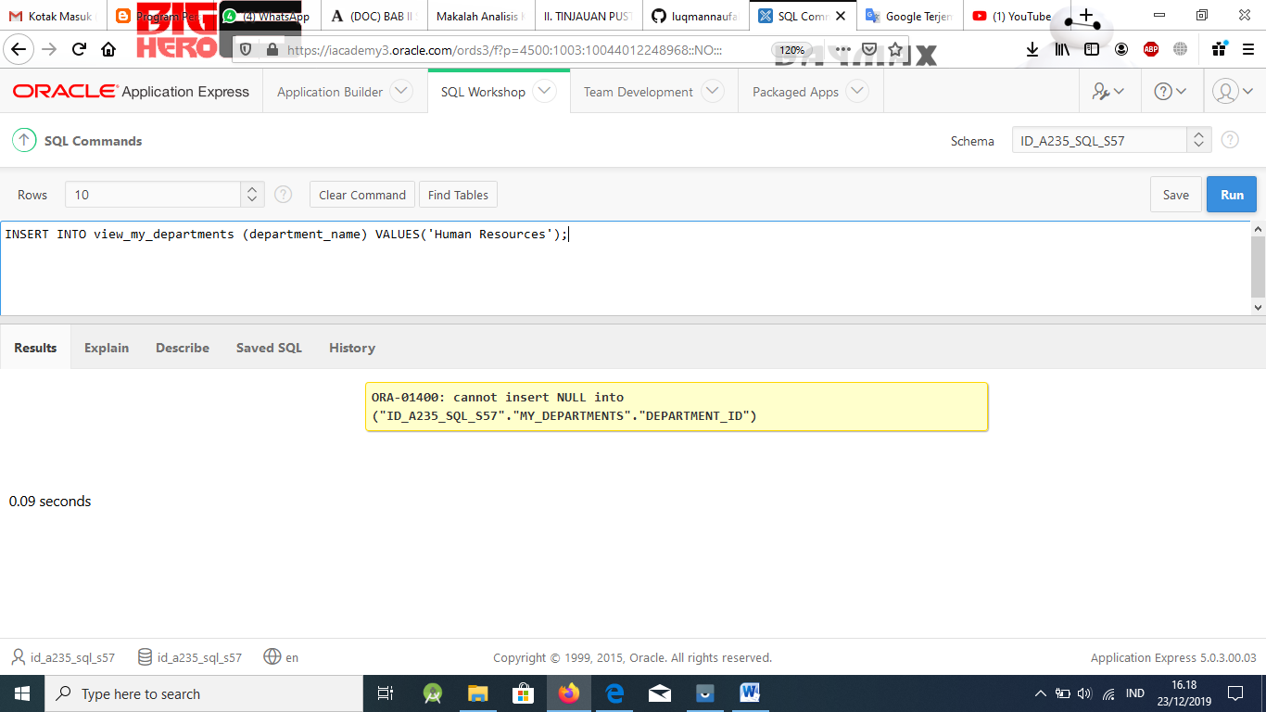

1. Add the Human Resources department, department ID 220, to my_departments using view_my_departments.

### Solution:

INSERT INTO view_my_departments (department_name, department_id) VALUES('Human Resources', 220);

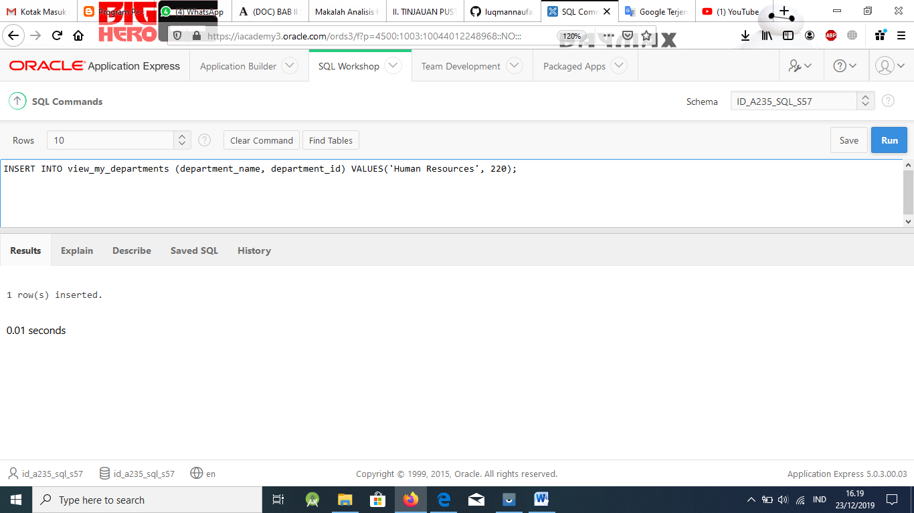

1. Verify that the new additions to my_departments were added using view_my_departments.

### Solution:

SELECT *

FROM view_my_departments; - See chart below

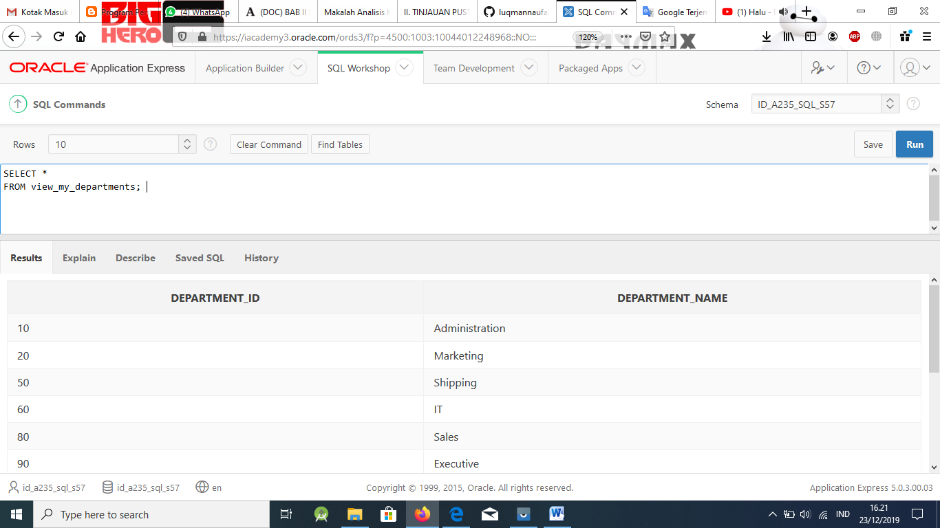

1. Modify view_my_departments to include location ID. Do a SELECT * command to show what columns are present and a DESCRIBE command to view the columns and associat- ed constraints.

### Solution:

CREATE OR REPLACE VIEW view_my_departments(department_name, department_id, location_id, manager_id)

AS SELECT department_name, department_id, location_id, manager_id FROM my_departments;

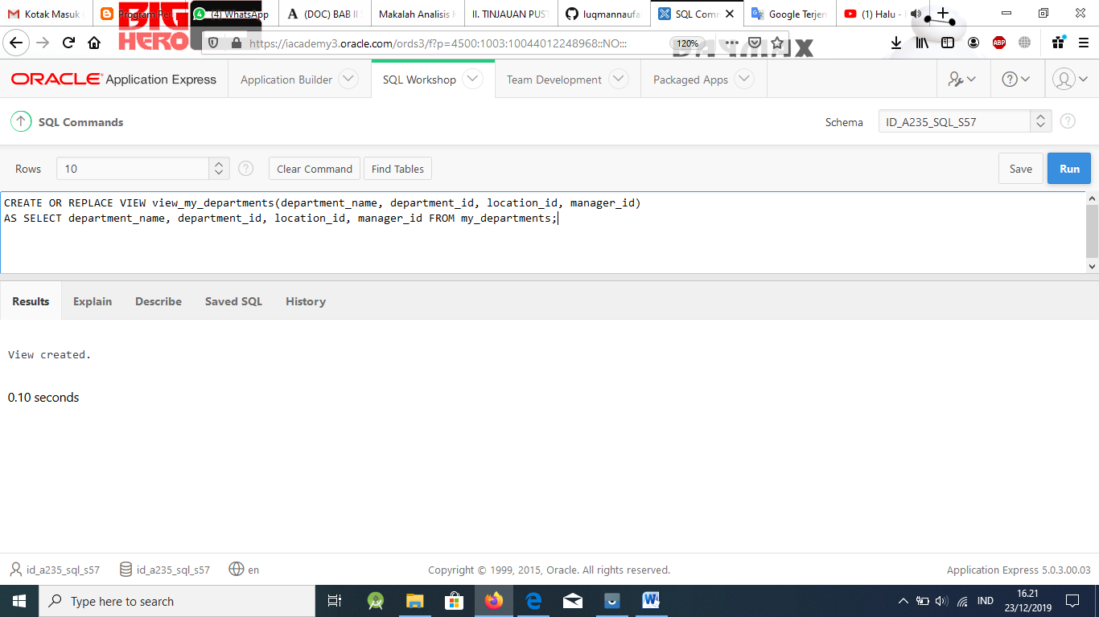

1. Make location_id a NOT NULL column in the my_departments table.

### Solution:

ALTER TABLE my_departments

ADD CONSTRAINT loc_id_my_dept_nn CHECK (location_id IS NOT NULL);

ORA-02293: cannot validate (USCA_ORACLE_SQL01_S01.LOC_ID_MY_DEPT_NN) - check constraint violated

** adding the three new columns to the my_departments table inserted null values in the location_id column. A NOT NULL constraint can only be added to a column if the table is empty or if the column has a value for every row.

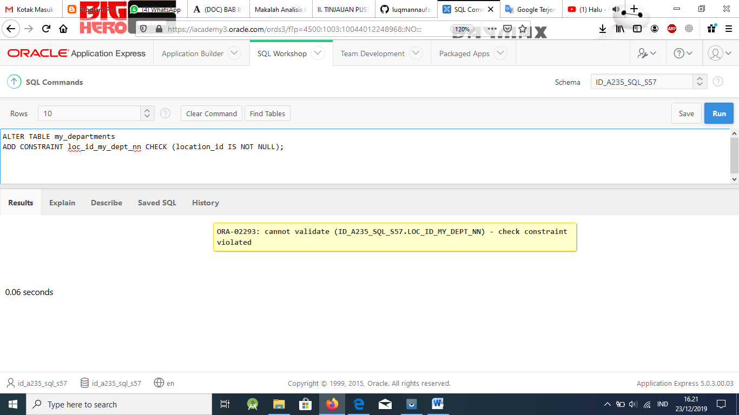

1. Using the Oracle database, create a complex view between locations and departments with only the following columns: department_name, street_address, city, and state. In- clude only U.S. cities. Verify that the view was created using a SELECT * statement.

### Solution:

CREATE VIEW view_dept_locations

AS SELECT d.department_name, l.street_address, l.city, l.state_province FROM departments d, locations l

WHERE d.location_id = l.location_id AND l.country_id LIKE 'US';

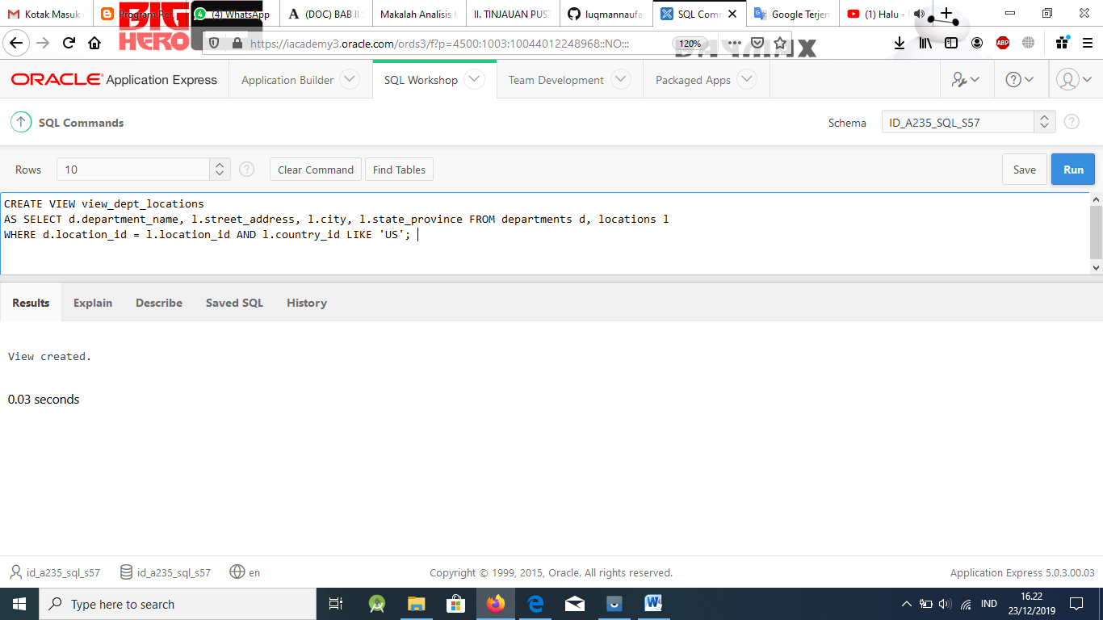

SELECT *

From view_dept_locations;

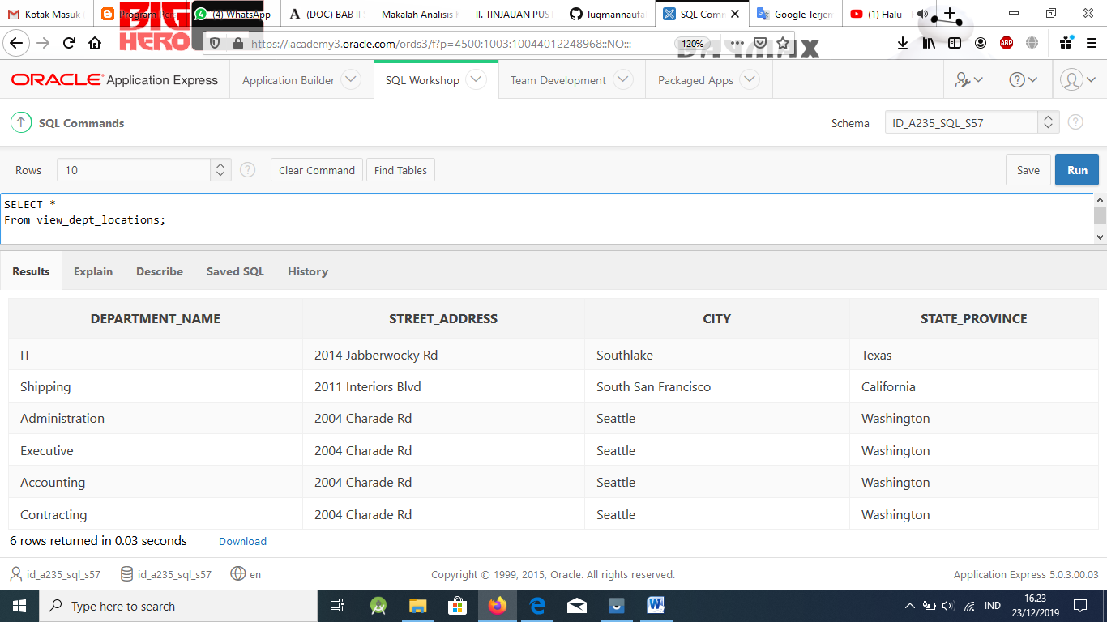

See chart below

|  |  |  |  |
| --- | --- | --- | --- |
| **DEPARTMENT_ID** | **DEPART- MENT_NAME** | **MANAGER_ID** | **LOCATION_ID** |
| 10 | Administration | 200 | 1700 |
| 20 | Marketing | 201 | 1800 |
| 50 | Shipping | 124 | 1500 |
| 60 | IT | 103 | 1400 |
| 80 | Sales | 149 | 2500 |
| 90 | Executive | 100 | 1700 |
| 110 | Accounting | 205 | 1700 |
| 190 | Contracting | (null) | 1700 |
| 105 | Advertising | (null) | (null) |
| 120 | Custodial | (null) | (null) |
| 220 | Human Re- sources | (null) | (null) |
| 130 | Planning | (null) | (null) |

|  |  |  |  |
| --- | --- | --- | --- |
|  |  |  |  |
| IT | 2014 Jabberwocky Rd | Southlake | Texas |
| Shipping | 2011 Interiors Blvd | South San Francisco | California |
| Administration | 2004 Charade Rd | Seattle | Washington |
| Executive | 2004 Charade Rd | Seattle | Washington |
| Accounting | 2004 Charade Rd | Seattle | Washington |
| Contracting | 2004 Charade Rd | Seattle | Washington |